School Name
Mathematics Test 2017
Year 7 |  | Introductory Algebra | Non Calculator  Section
Skills and Knowledge Assessed:  - Introduce the concept of variables as a way of representing numbers using letters (ACMNA175)  - Extend and apply the laws and properties of arithmetic to algebraic terms and expressions (ACMNA177)  - Simplify algebraic expressions involving the four operations (ACMNA192) |  |  | Name___________________
Answer all questions in the spaces provided on this test paper by:
Writing the answer in the box provided.
or
Shading in the bubble for the correct answer from the four choices provided.
Show any working out on the test paper. Calculators are not allowed.
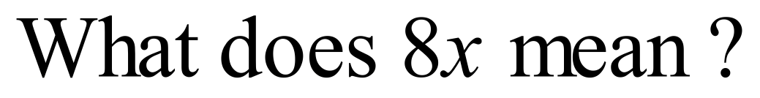

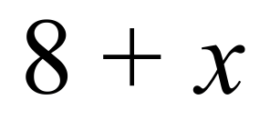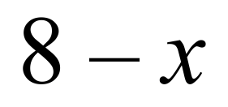
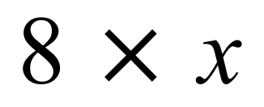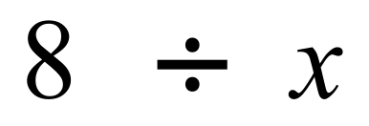
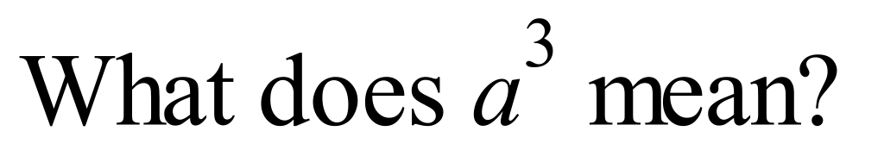
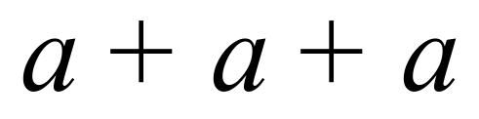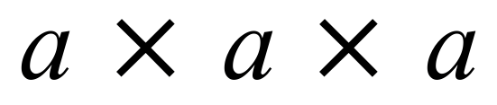
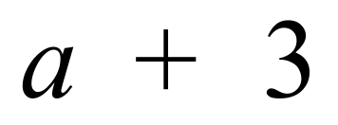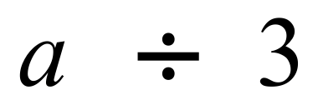
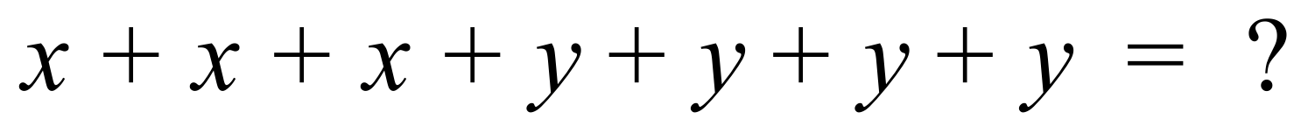
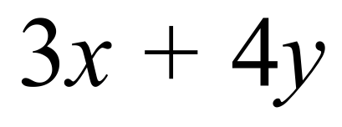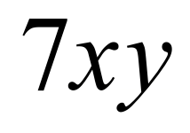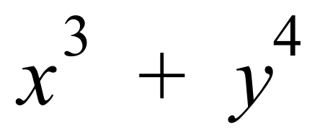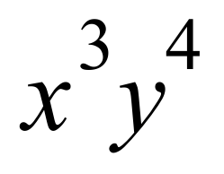
 | Write an expression for the number of minutes in h hours.
 | Simplify 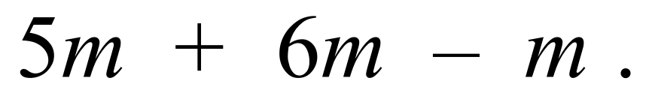
 | Simplify 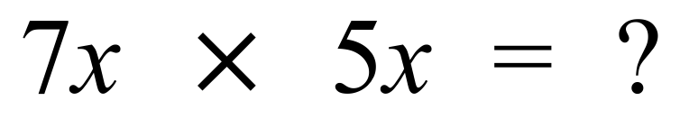
 | –6 –4 –3 3
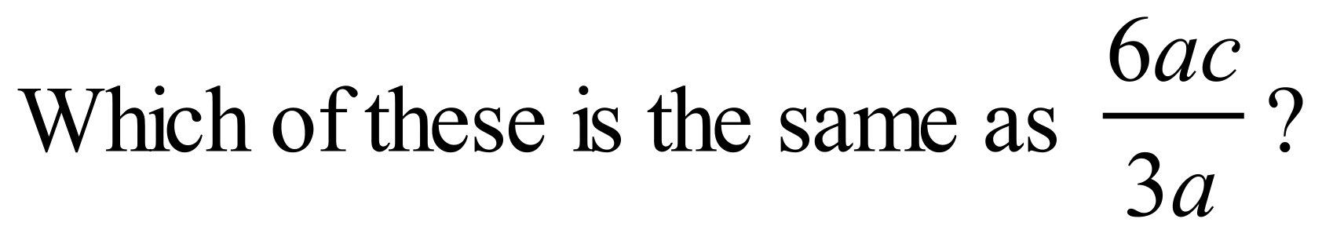

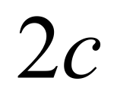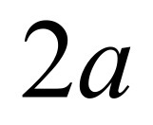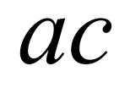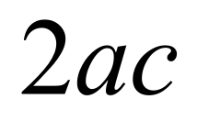
Which of these does not simplify to 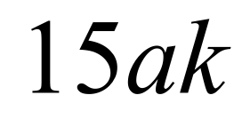 ?

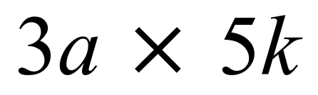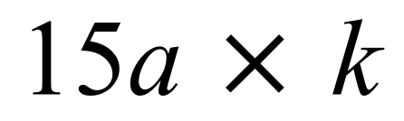
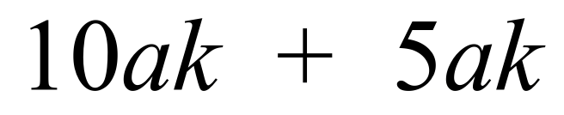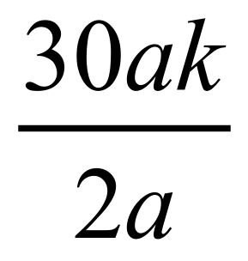
 | Simplify 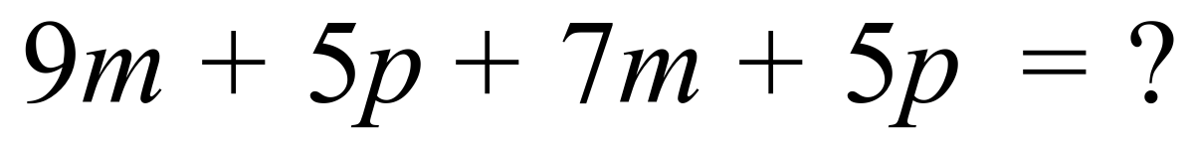
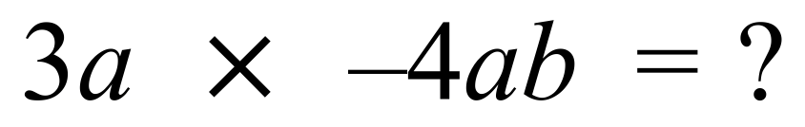

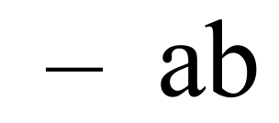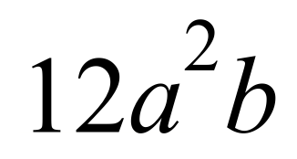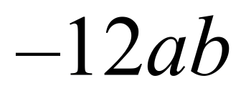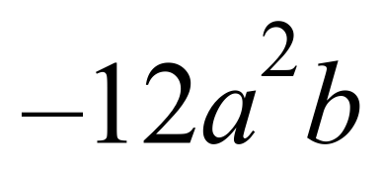
 | Simplify 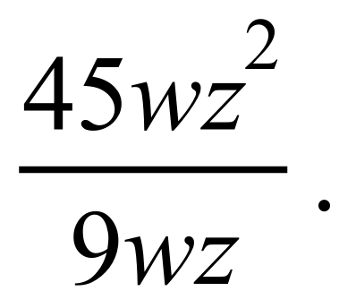
Simplify 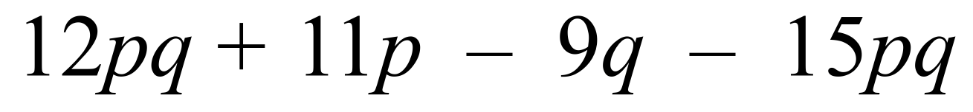

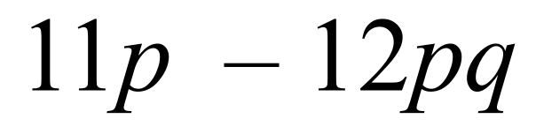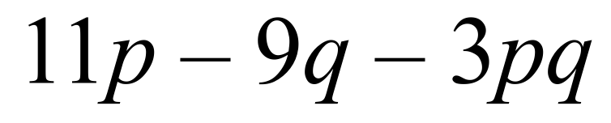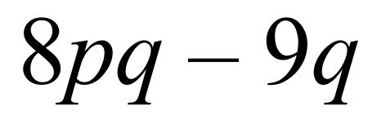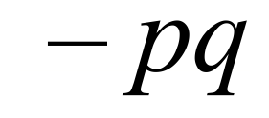
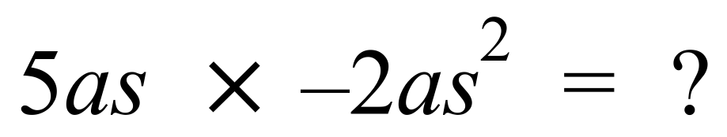

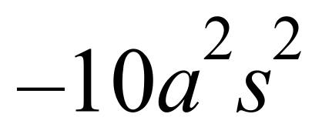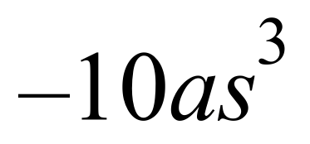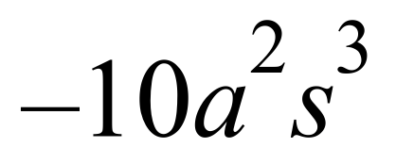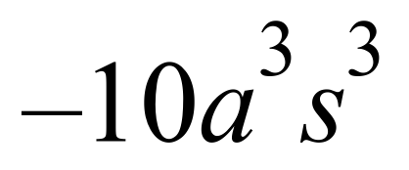
Angela’s teacher asked her to write an expression for :
“The sum of the square of x and a third of x.”
Which of these algebraic expressions could represent this?
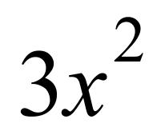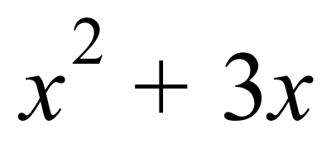
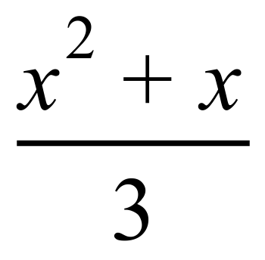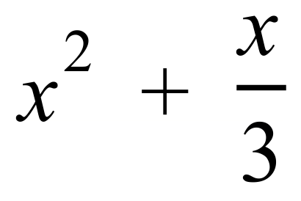
 | Simplify 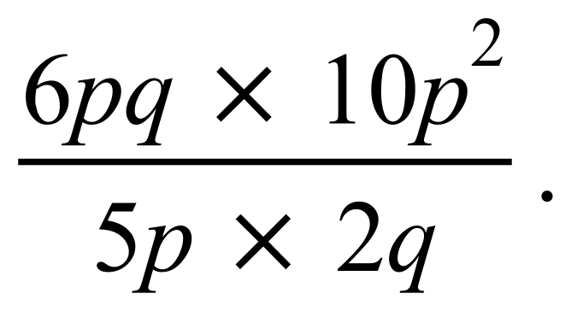
Complete the two missing values in the table below for the expression 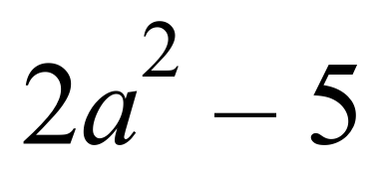 ?

a | –2 | –1 | 3
 |  | –3

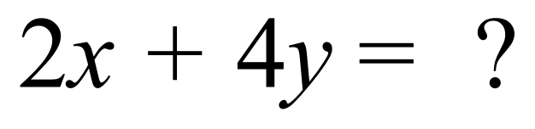

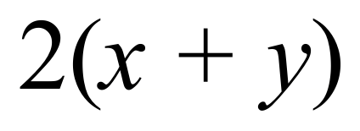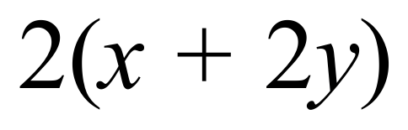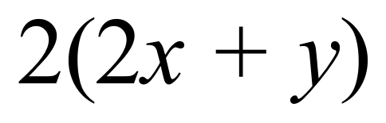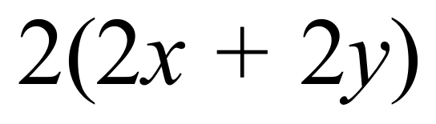
A bus has x seats each of which holds 2 people and it can also take y people standing.
How many people can the bus take when full?

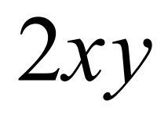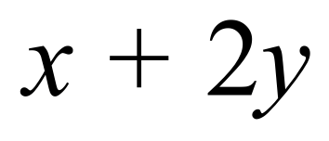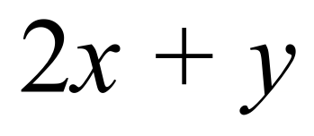
A rectangular paddock measures a metres long and x metres wide.
What is an expression for the perimeter of the paddock (distance around the outside).

Using n for the number, write an expression in algebraic symbols for the following.
“Take any number, square it and subtract 4, then multiply the result by 6.”

School Name
Mathematics Test 2017
Year 7 |  | Introductory Algebra | Calculator Allowed  Short Answer  Section
 |  |  | Name___________________
Answer all questions in the spaces provided on this test paper by:
Writing the answer in the box provided.
or
Shading in the bubble for the correct answer from the four choices provided.
Show any working out on this test paper. Calculators are allowed.
 | Simplify 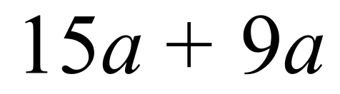.
 | Simplify 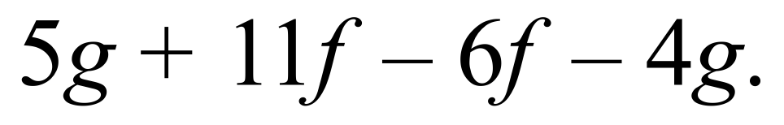
 | If 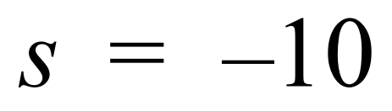 what is the value of 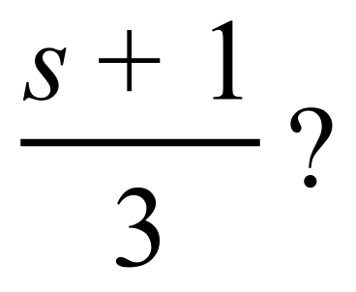
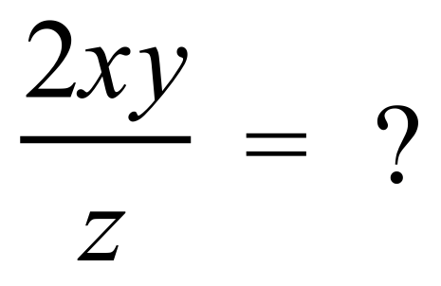

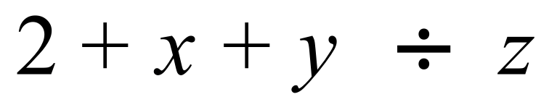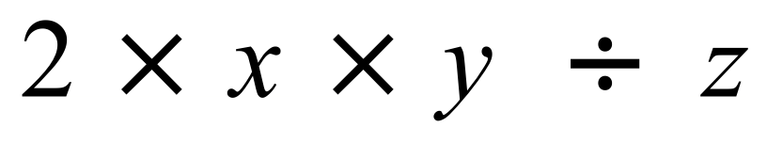
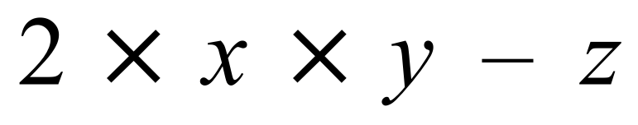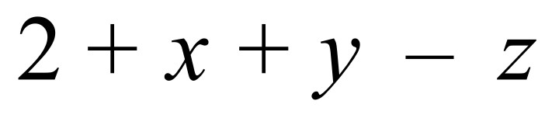
 | Write 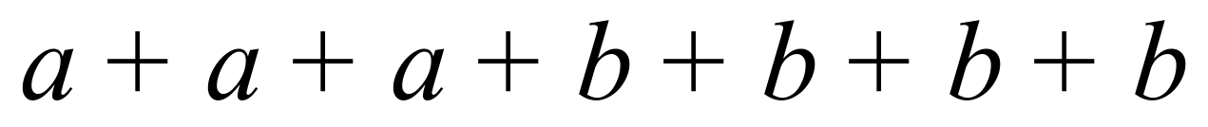 in a shortened form.
Simplify 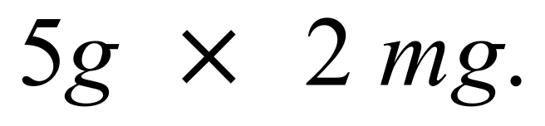

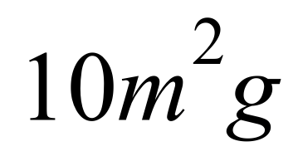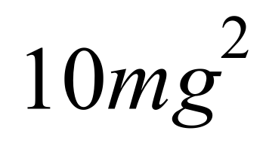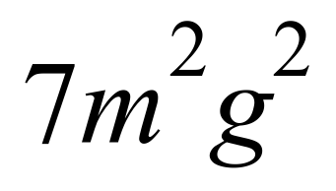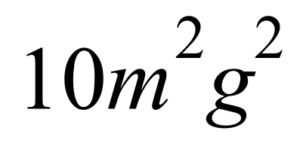
 | Write an expression that means “Take the sum of the squares of x and y.”
The same number of dice are put into each of 8 cups, and there are 5 dice left over.
If c is the number of dice in each cup, which is an expression for the total number of dice?

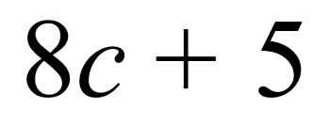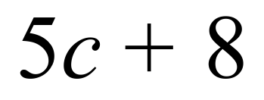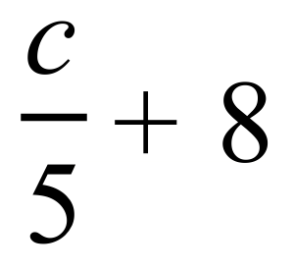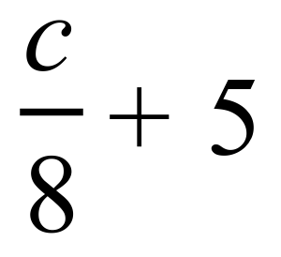

 | 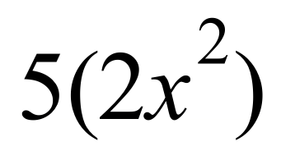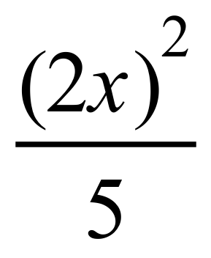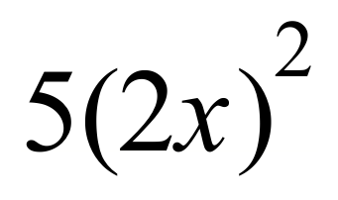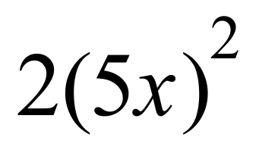
 | 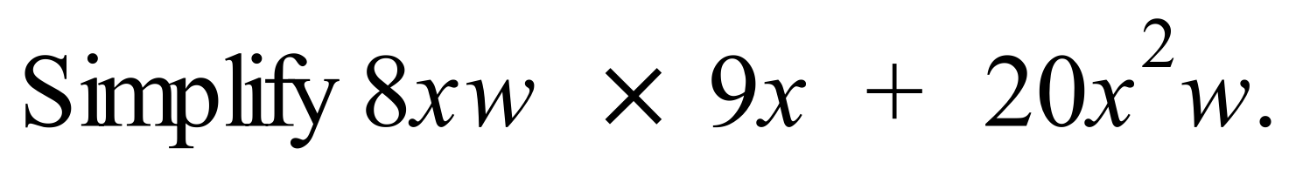
Which of the following does not simplify to give 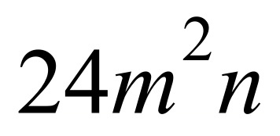 ?

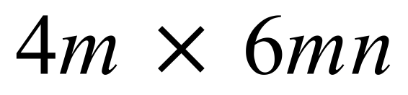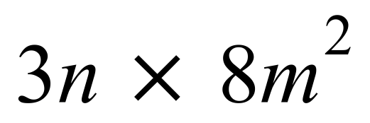
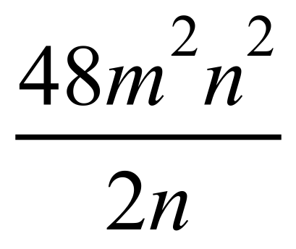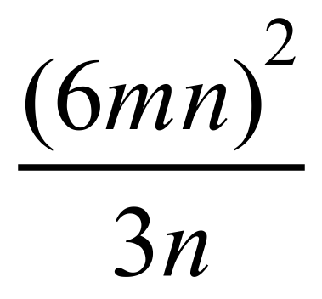
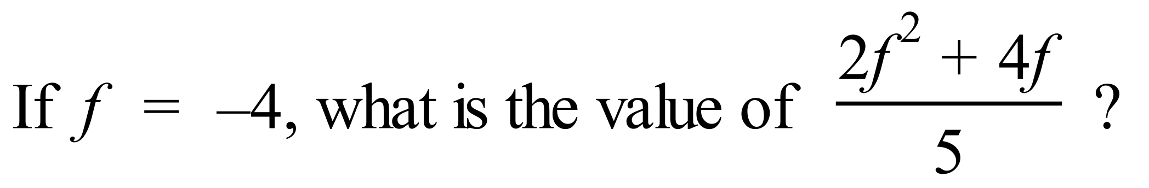

–6.4 –3.2 0 3.2
Simplify

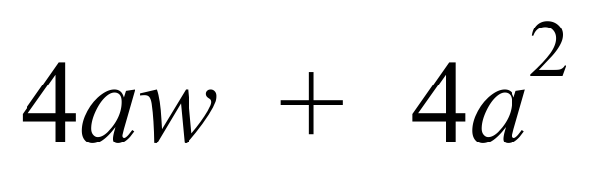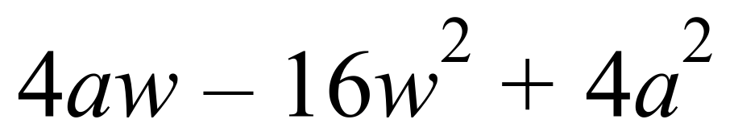
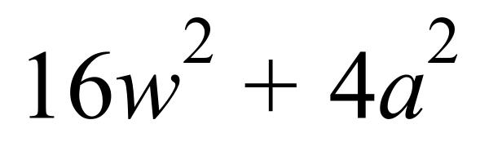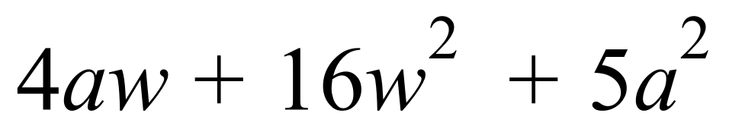
When 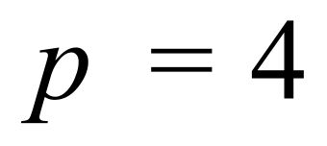 , 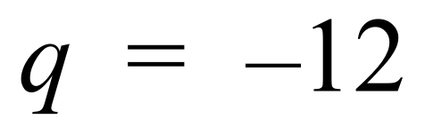 and 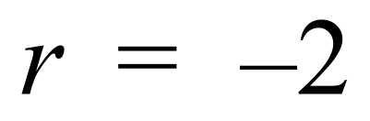 what is the value of 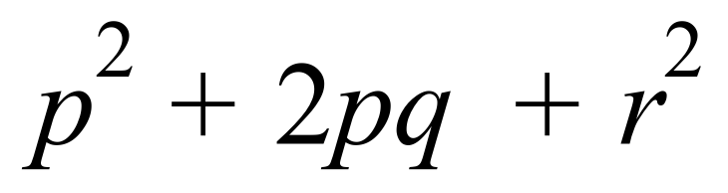

–84 –80 –76 –54
 | Simplify 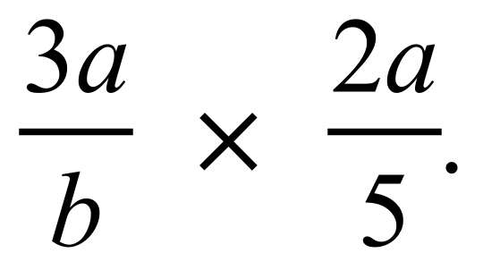
`

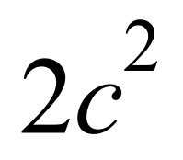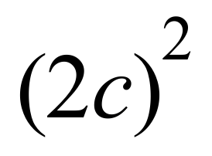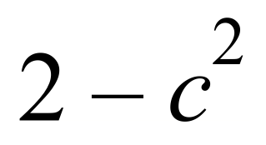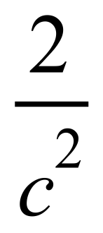
 | –6 –2 1 2
 | 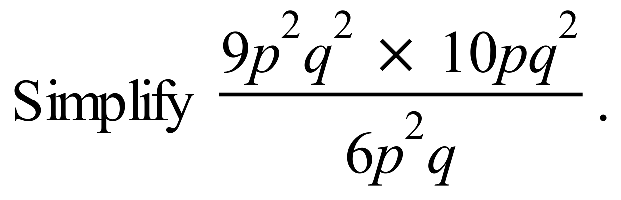
Which expression is not equal to 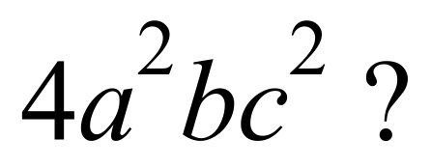

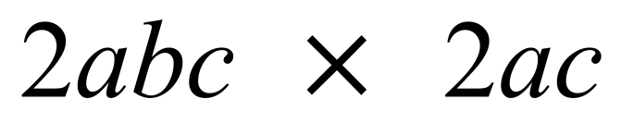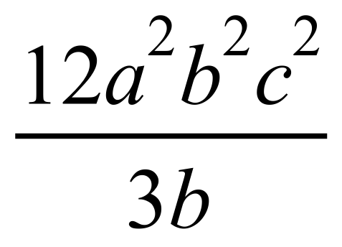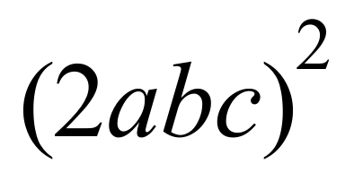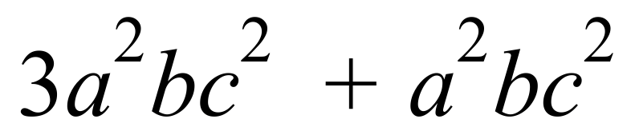
Which of these means the same as 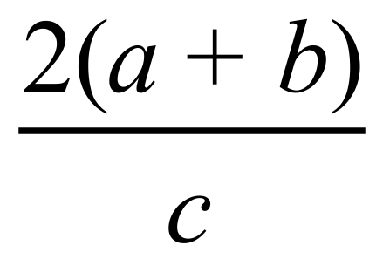 .

Double the sum of a and b and divide the result by c.
Divide the sum of a and b by c and double the result.
Take the sum of b and twice a and divide the result by c.
Divide the a by c, add b and double the result.
Which of these is always true, regardless of the value of a?

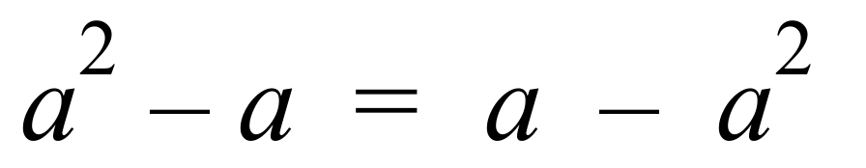
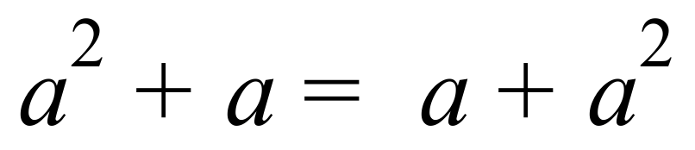
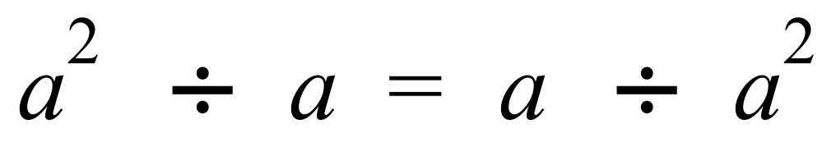
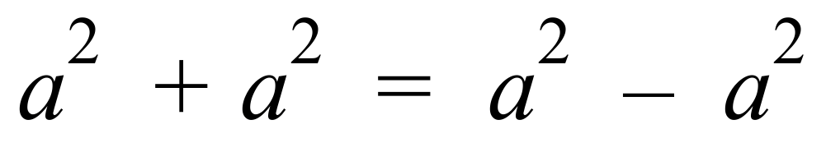

School Name
Mathematics Test 2017
Year 7 | Introductory Algebra | Non Calculator Section
ANSWERS

Question | Working and Answer
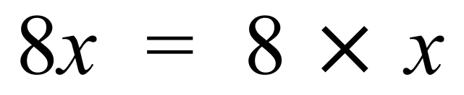
3rd Answer
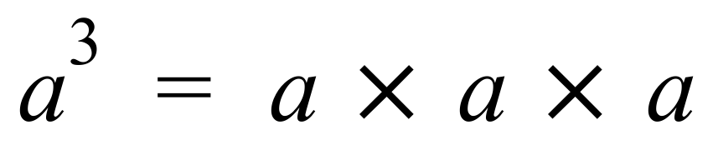
2nd Answer
 | 1st Answer
 | 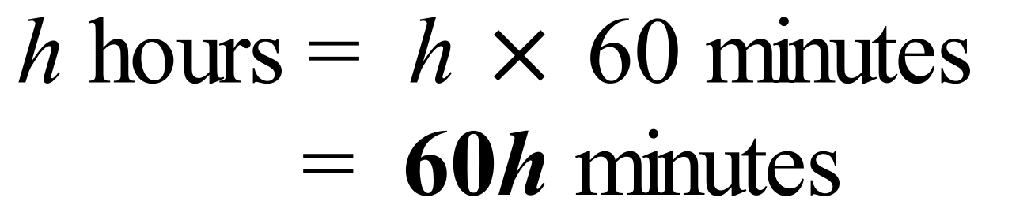
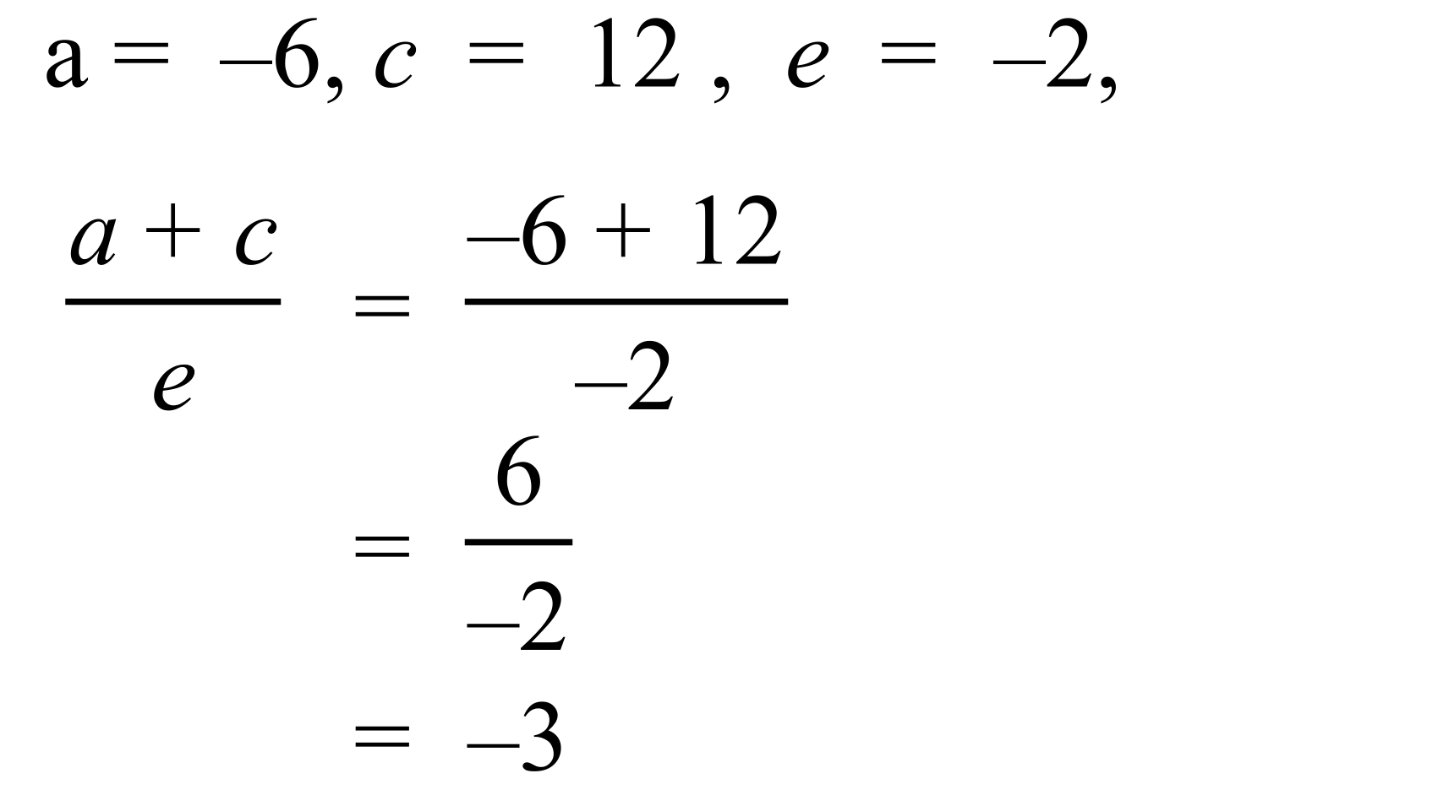
3rd Answer
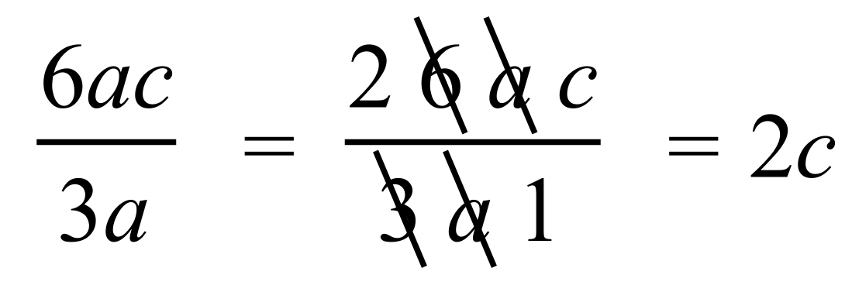
1st Answer
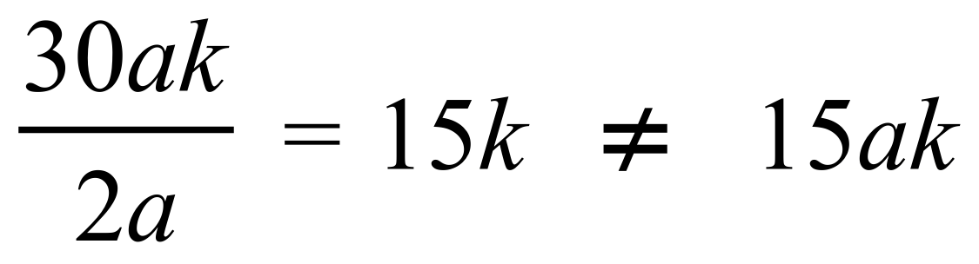
4th Answer
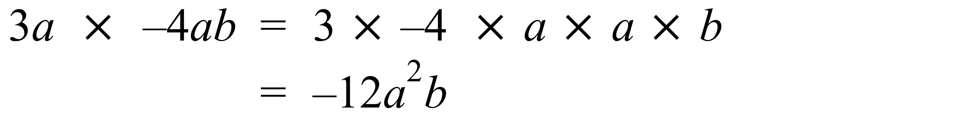
4th Answer
 | 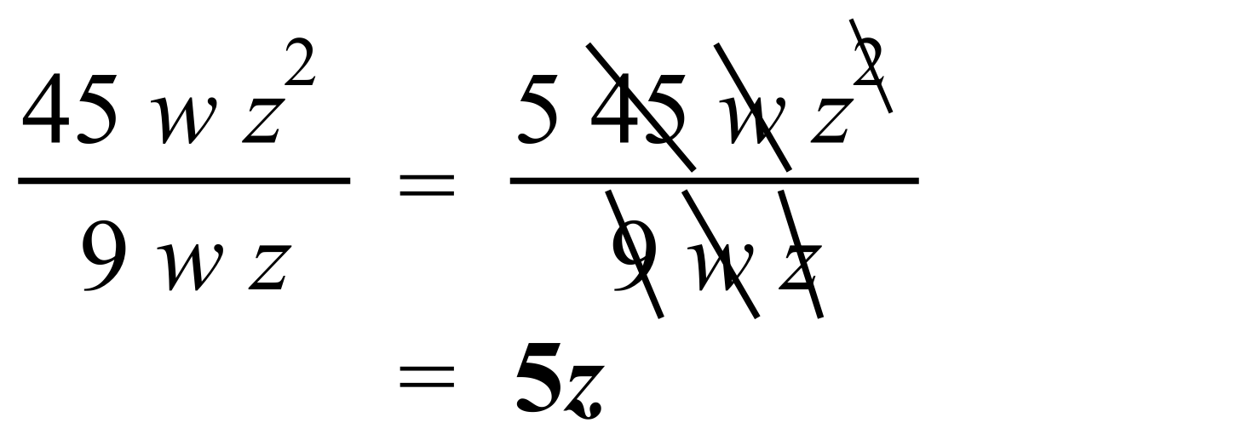
 | 2nd Answer
 | 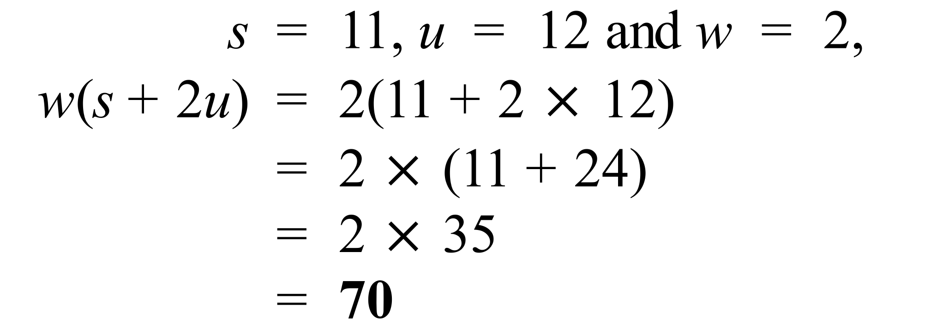
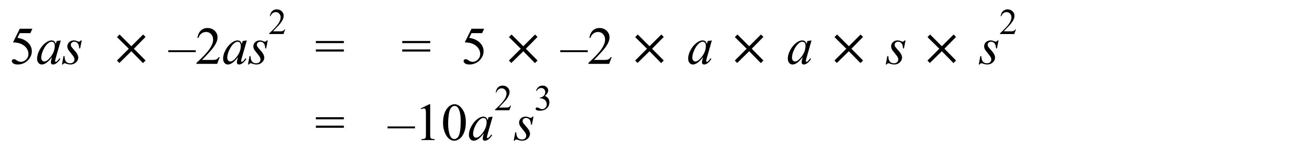
3rd Answer
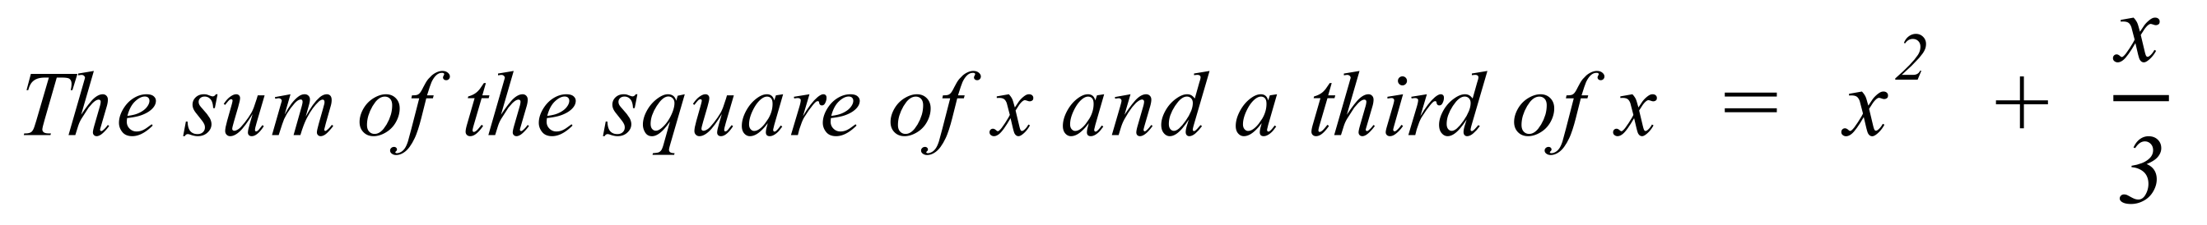
4th Answer
 | 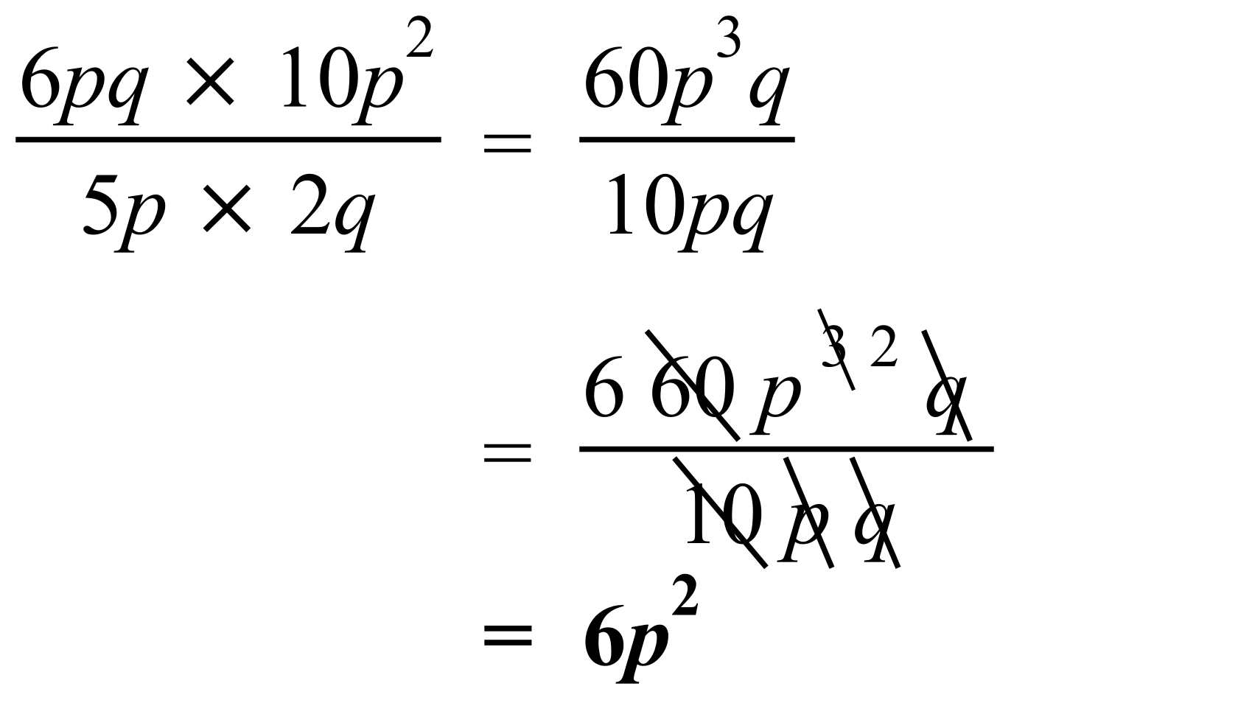
a | –2 | –1 | 3
 | 3 | –3 | 13

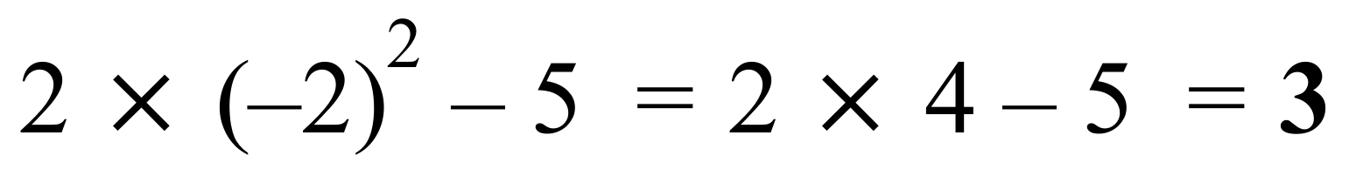
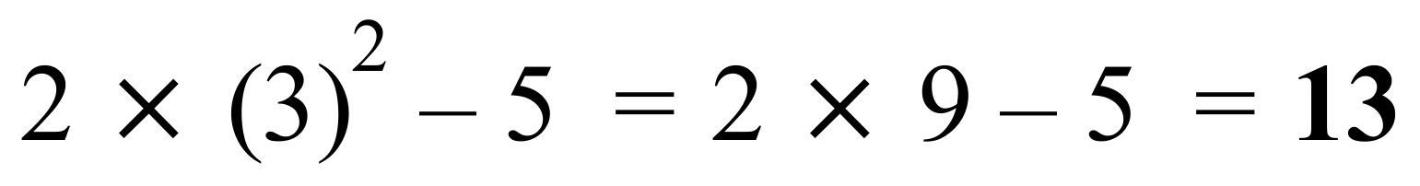
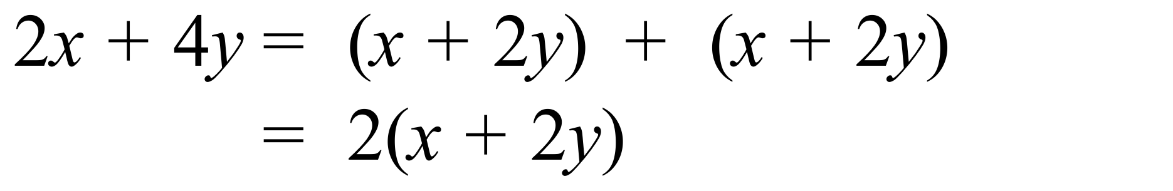
2nd Answer
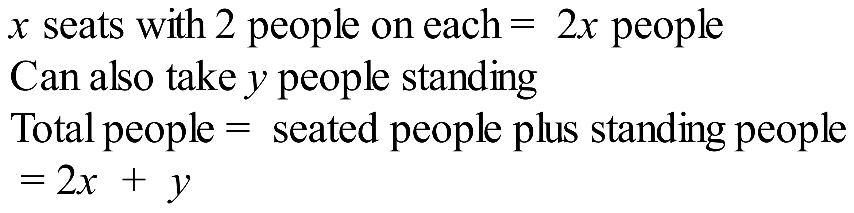
3rd Answer
 | 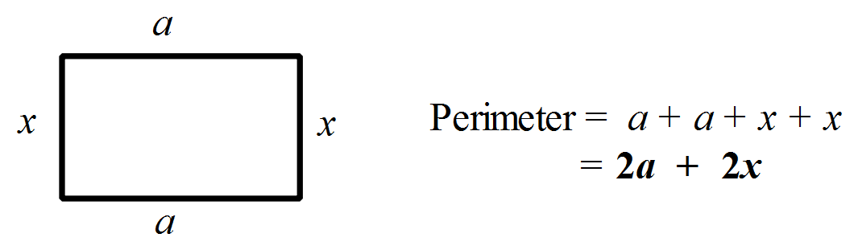
“Take any number (n)
Square it gives n²
Subtract 4, gives n² – 4
Multiply the result by 6 gives 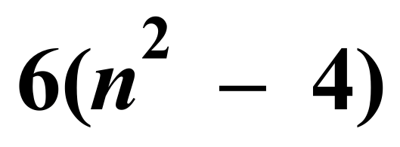

School Name
Mathematics Test 2017
Year 7 | Introductory Algebra | Calculator Allowed  Short Answer  Section

ANSWERS
Question | Working and Answer
 | 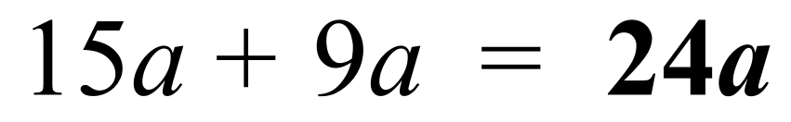
 | 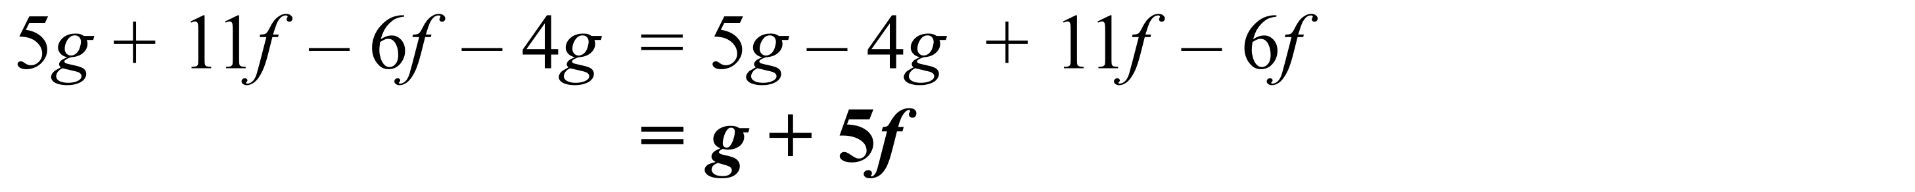
 | 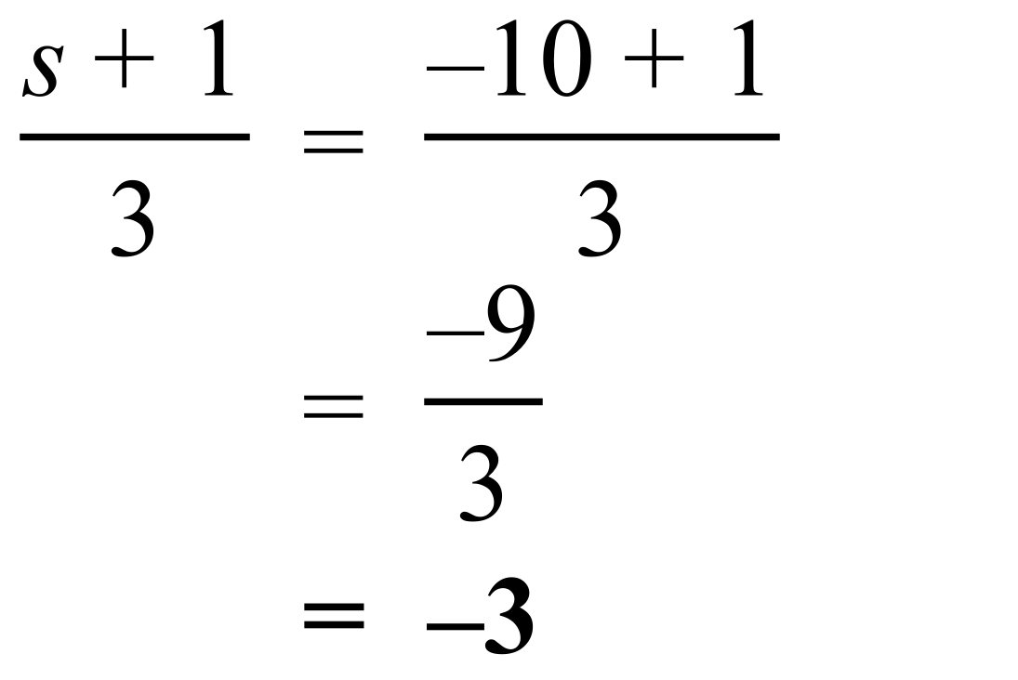
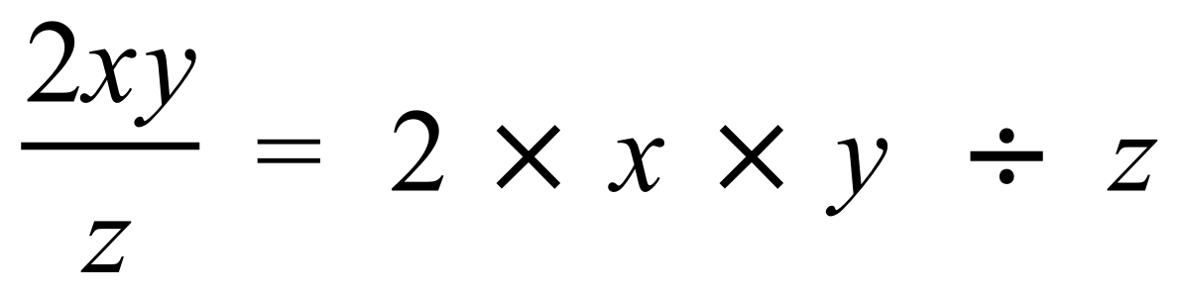
2nd Answer
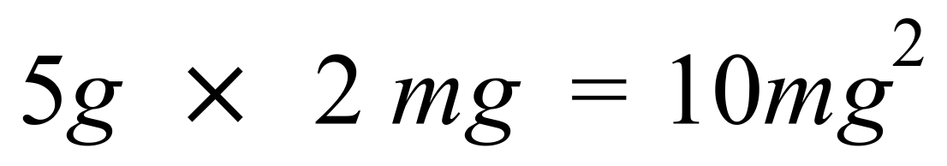
2nd Answer
The squares of x and y are x² and y².
Taking the sum of these is x² + y²
The 8 cups hold 8 × c = 8c dice.
So altogether there were 8c + 5
1st Answer
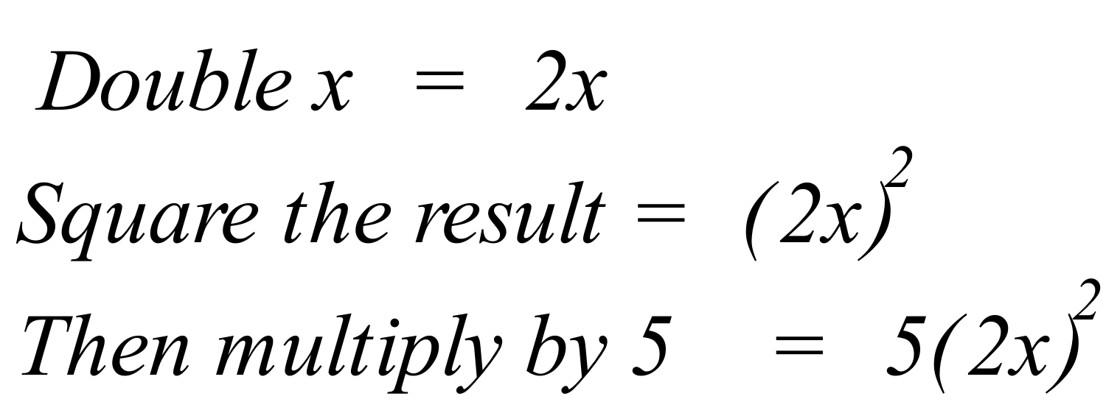
3rd Answer
 | 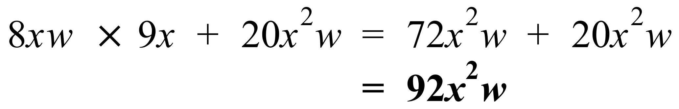
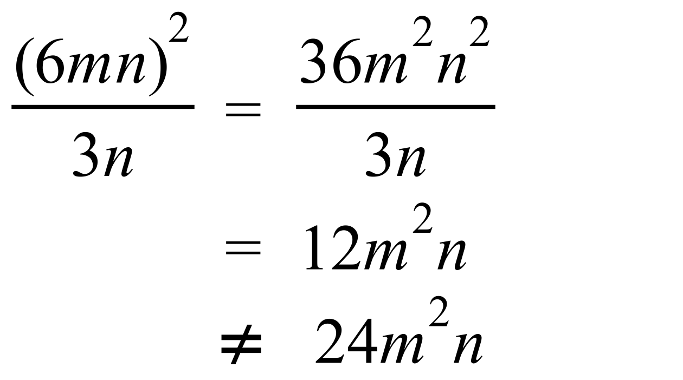
4th Answer
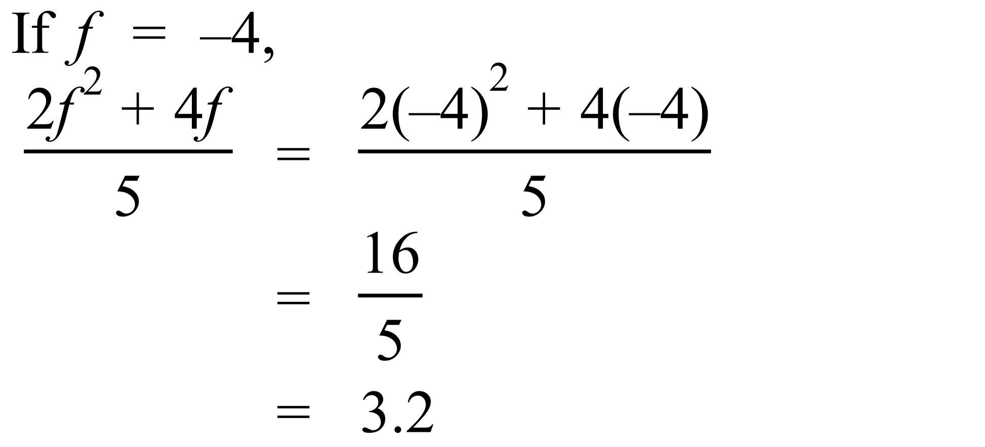
4th Answer
 | 1st Answer
When , and 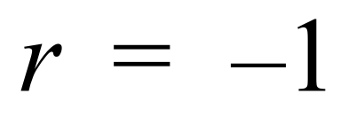
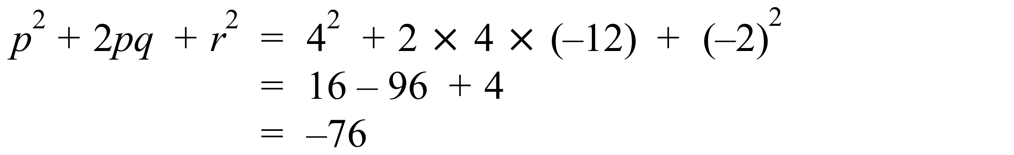
3rd Answer
 | 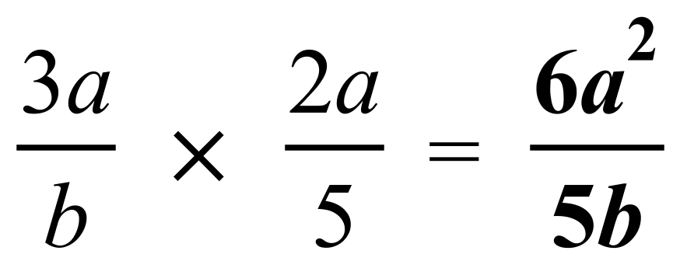
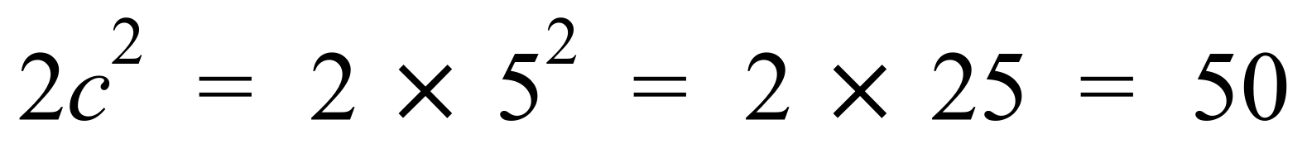
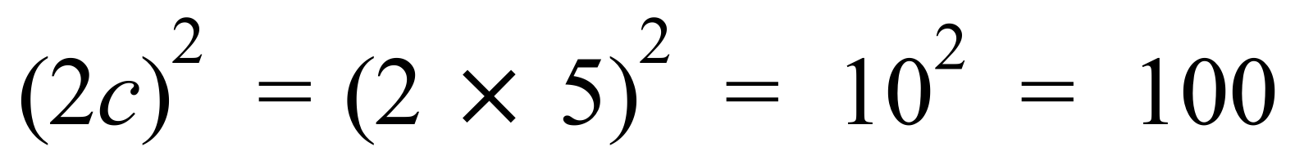
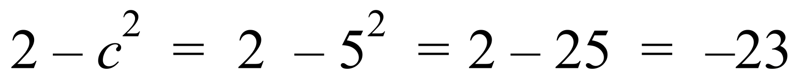
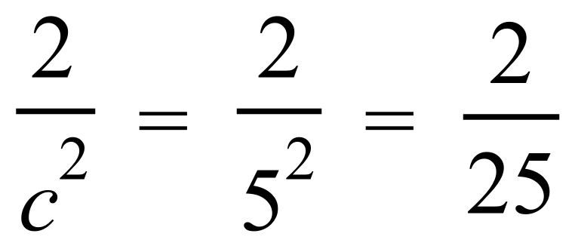
Greatest value is 100
2nd Answer
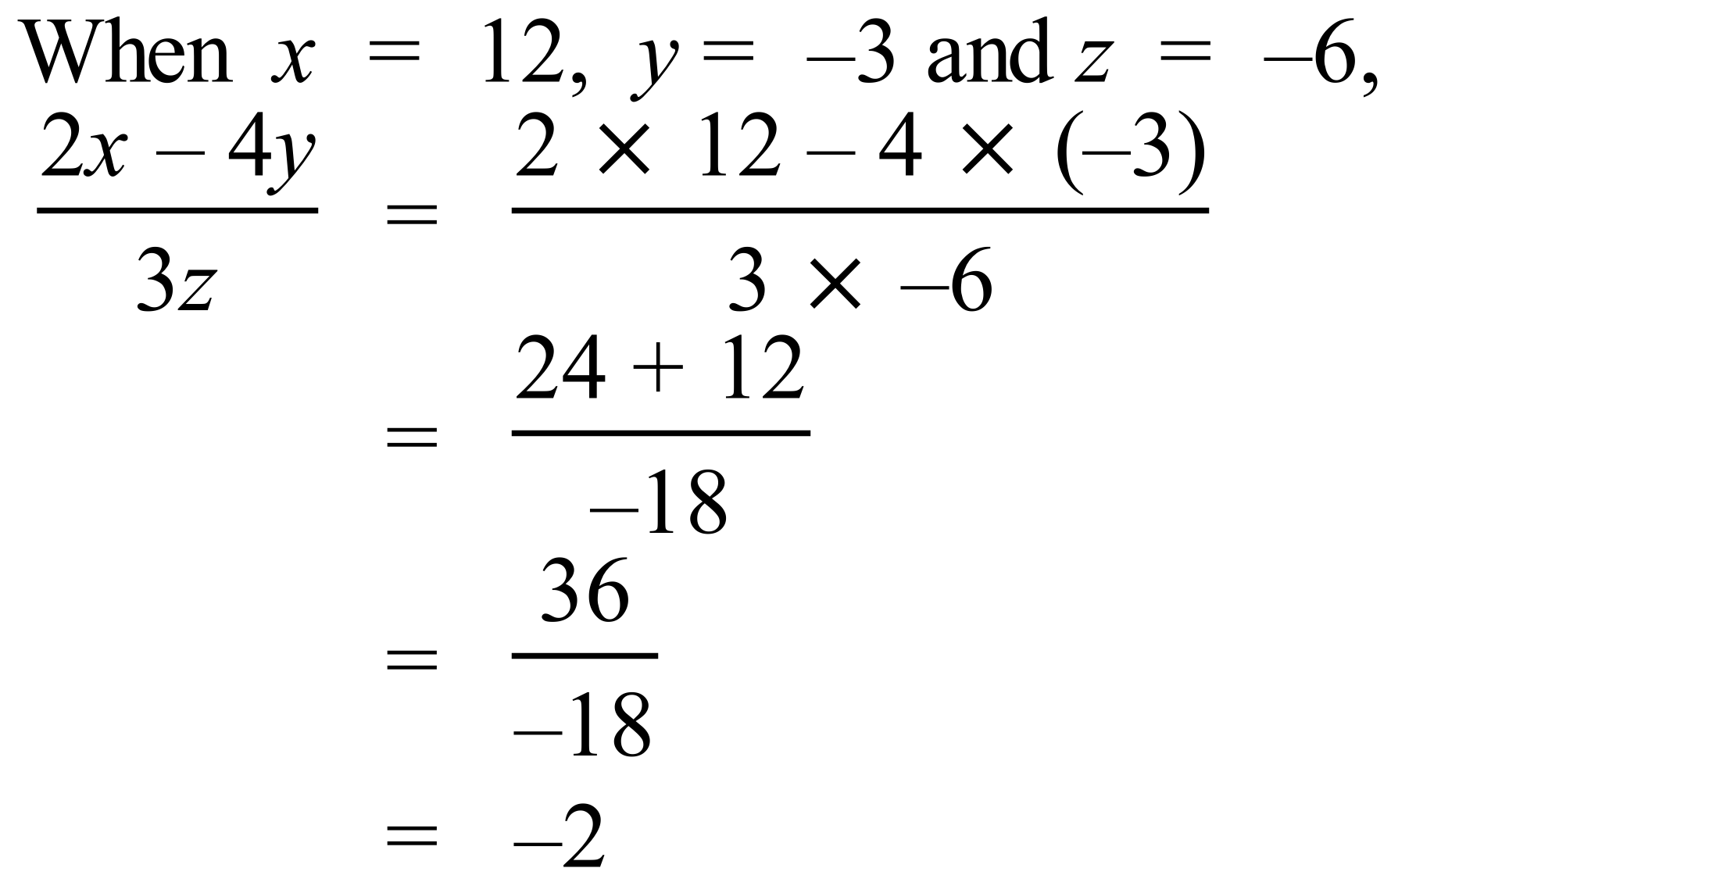
2nd Answer
 | 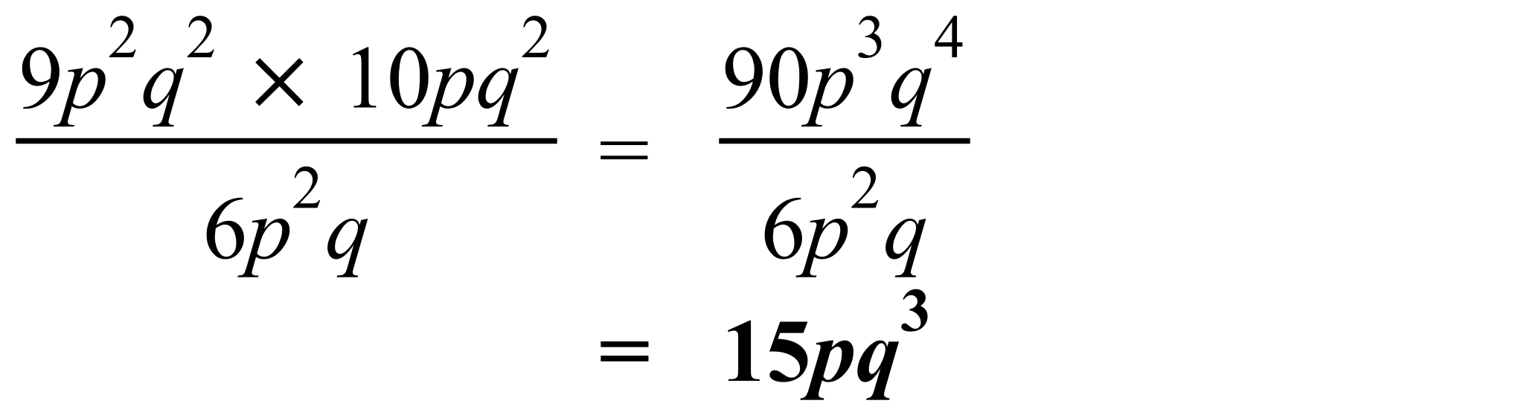
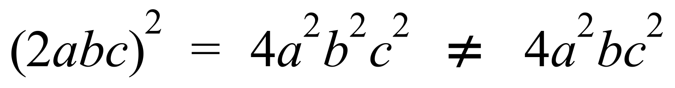
3rd Answer
 | 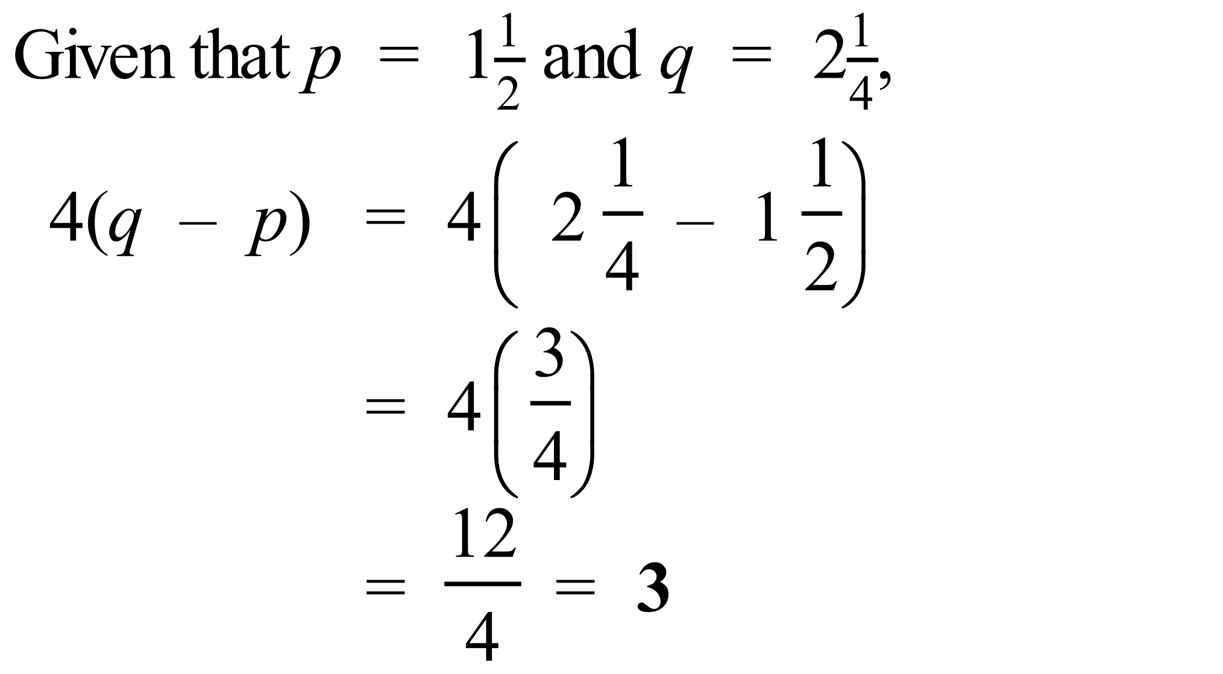
Double the sum of a and b and divide the result by c. 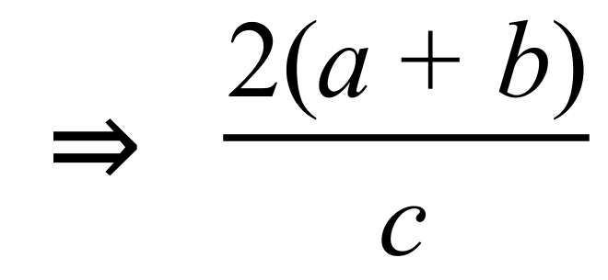
Divide the sum of a and b by c and double the result.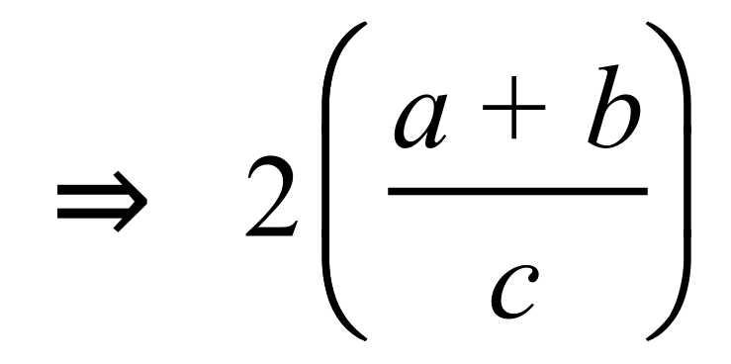
Take the sum of b and twice a and divide the result by c.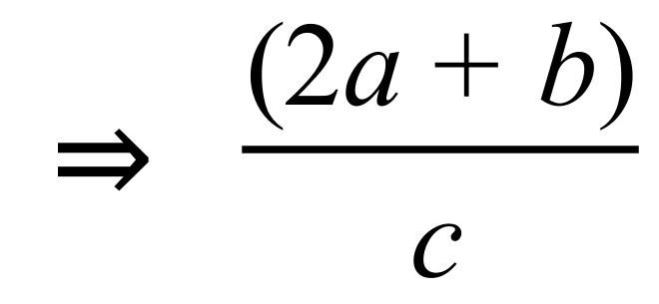
Divide the a by c, add b and double the result.. 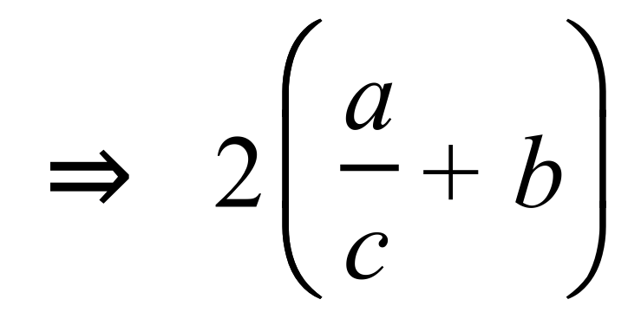
1st Answer
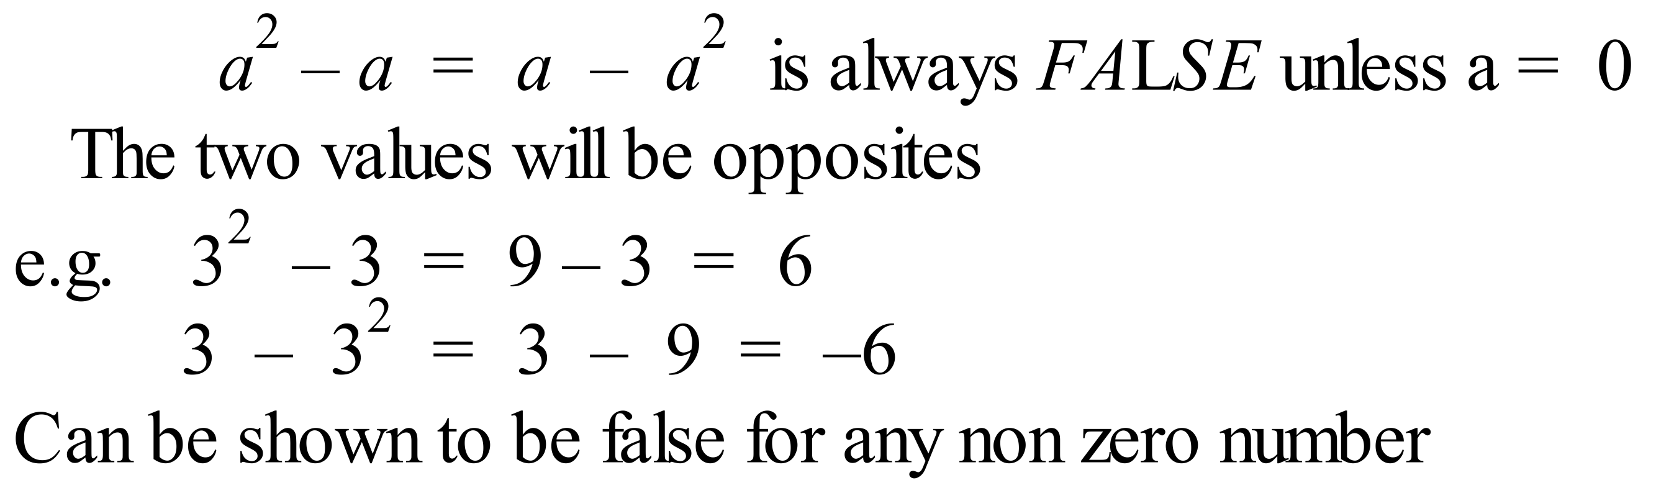
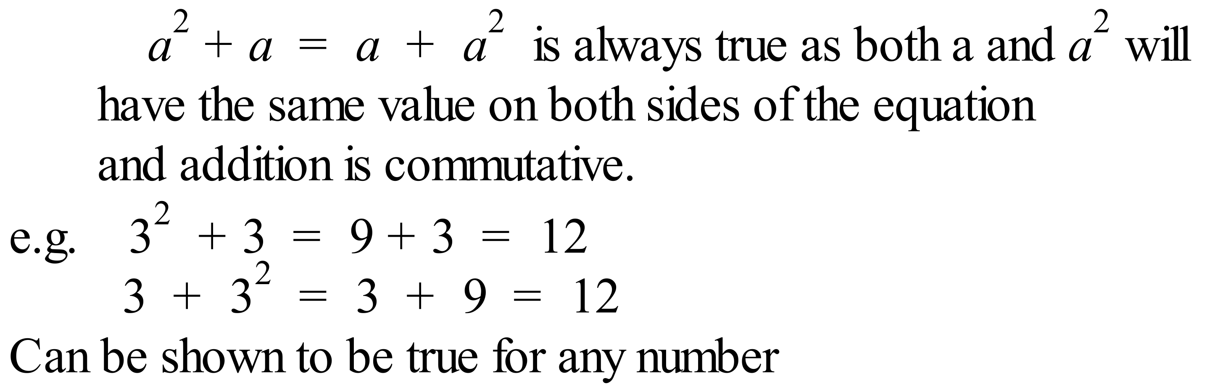
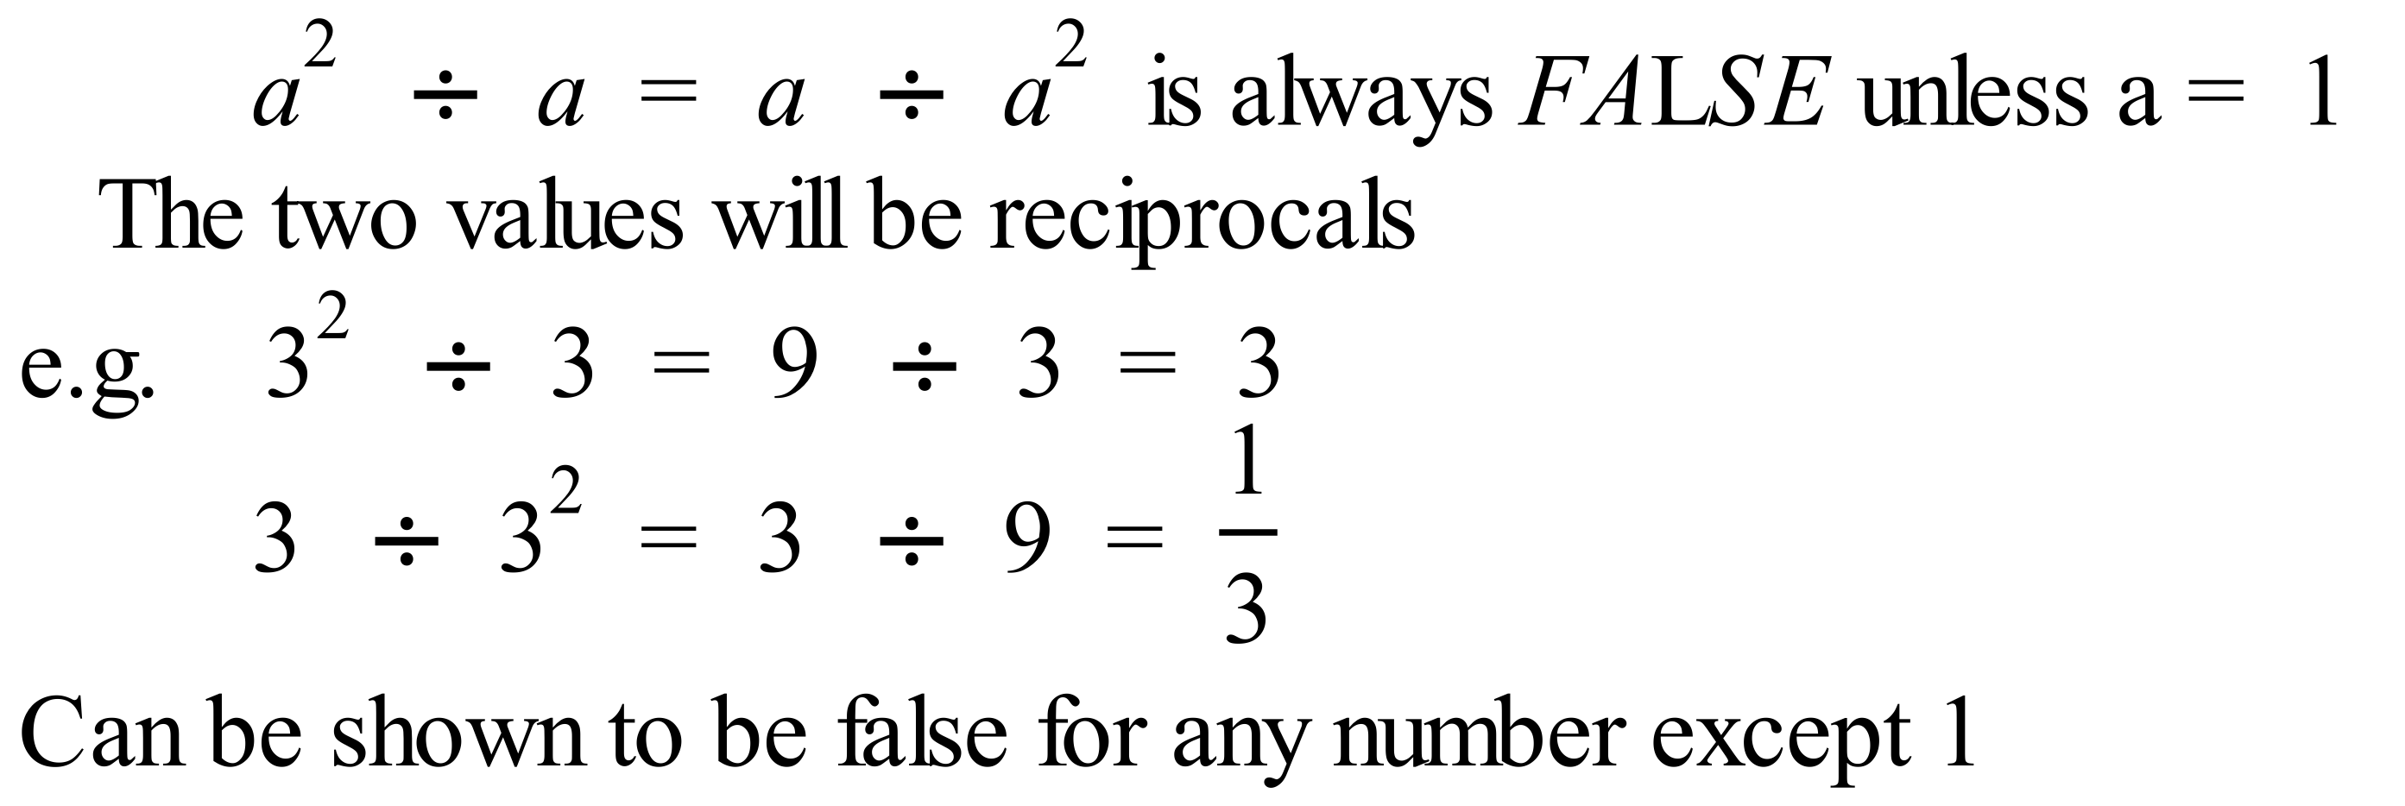

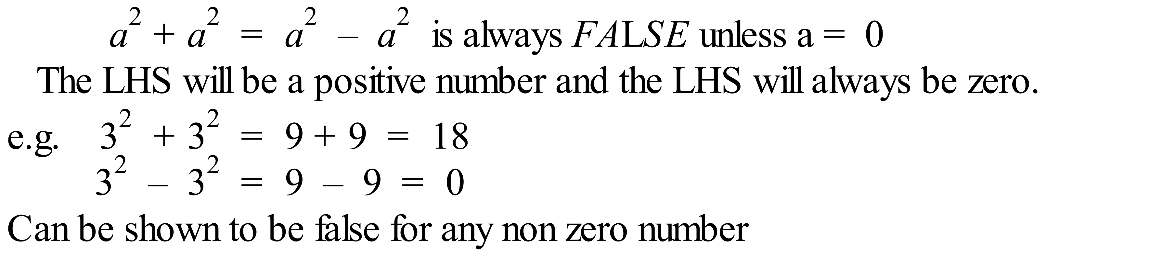
2nd Answer

